Unit 1
INTRODUCTION TO CLOUD COMPUTING

(6 Hours)
. 1.1 Cloud computing overview and evolution
. 1.2 Characteristics of cloud computing
. 1.3 Benefits and challenges
. 1.4 Applications of cloud computing
. 1.5 Introduction to cloud storage
. 1.6 Cloud service requirements
. 1.7 Dynamic infrastructure
. 1.8 Cloud adoption strategies and case studies
  - Cloud computing overview and evolution

Meaning of Cloud Computing
Cloud computing means using computing resources such as servers, storage, software, databases, networking, and applications through the internet instead of installing and maintaining everything on a local computer or local server.
In simple words:
Cloud computing is like renting computing power, storage, or software from a service provider through the internet.

Simple Example
Before cloud computing, a college needed its own physical server to host a website, store student data, and run applications. The college had to buy hardware, install software, maintain security, manage backup, and repair failures.
With cloud computing, the college can use services such as Google Drive, Microsoft 365, AWS, Azure, or Google Cloud. The servers are managed by cloud providers, and the college uses the services through the internet.

Traditional Computing vs Cloud Computing
Traditional Computing | Cloud Computing
Hardware is purchased by the organization | Hardware is rented from cloud provider
High initial cost | Pay-as-you-use cost
Maintenance is done by own IT team | Maintenance is done by provider
Scaling is difficult |  | Scaling is easy
Data usually stored locally |  |  | Data stored in cloud data centers
Backup must be managed manually |  |  | Backup can be automated

Evolution of Cloud Computing
Cloud computing did not appear suddenly. It evolved from earlier computing models.

1. Mainframe Computing
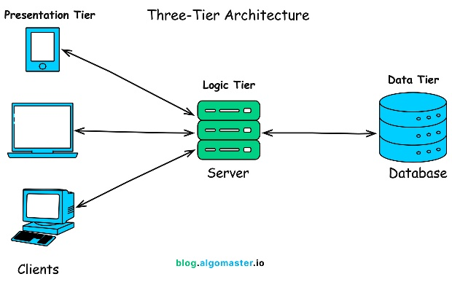
In early computing, large mainframe computers were used by many users through terminals. The main computer performed all processing.

Example: Banks used mainframe computers for customer account processing.

2. Client-Server Computing
In this model, clients request services from a server. The server stores data and applications.
Example: A college management system installed on a local server and accessed by computers inside the college network.

3. Distributed Computing
Computing tasks are divided among multiple computers connected through a network.
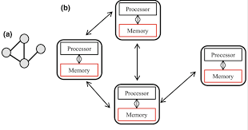
Example: Scientific research systems using multiple computers to process large data.

4. Grid Computing
Different computers from different locations are connected to solve large problems.
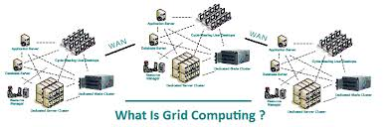
Example: Weather forecasting, space research, and scientific simulations.

5. Virtualization
Virtualization allows one physical server to run multiple virtual machines.

Example: One physical server can run Windows Server, Linux Server, and database server separately as virtual machines.
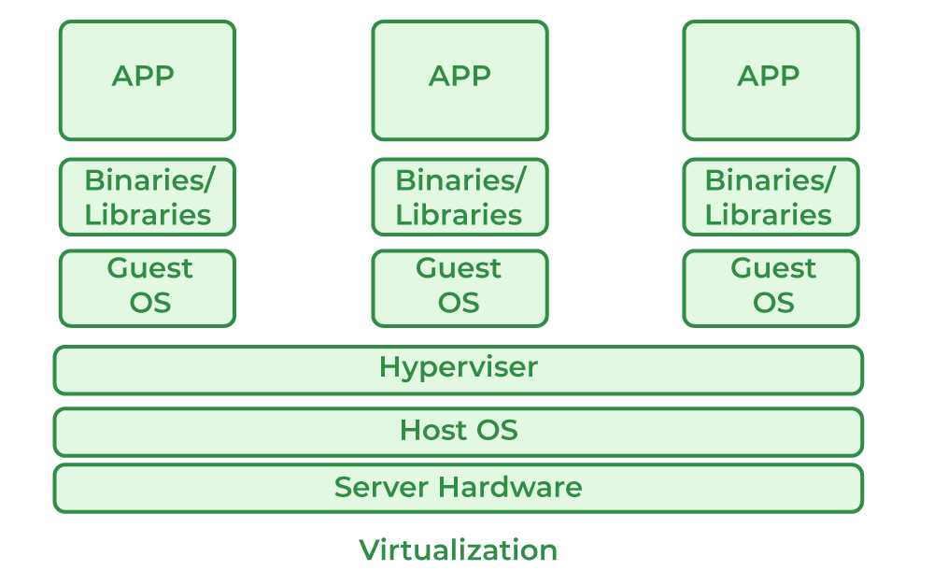

6. Cloud Computing
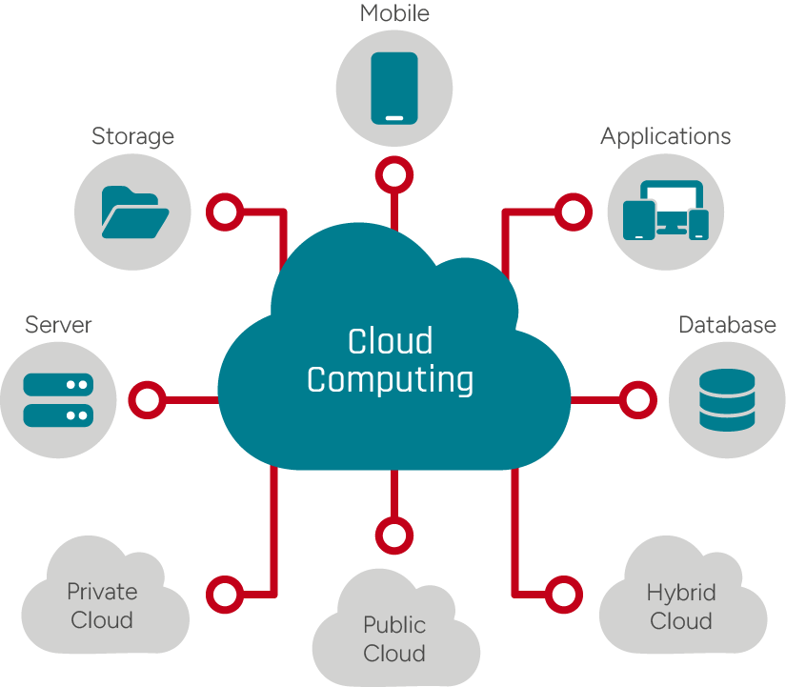
Cloud computing combines virtualization, internet, automation, storage, and distributed systems to provide computing services on demand.

Evolution Flow
Mainframe Computing
↓
Client-Server Computing
↓
Distributed Computing
↓
Grid Computing
↓
Virtualization
↓
Cloud Computing

  - Characteristics of cloud computing

Cloud computing has some important characteristics that make it different from traditional computing.
1. On-Demand Self-Service
Users can use cloud services whenever needed without directly contacting the service provider.
Example:
A student creates a Google Drive account and starts storing files immediately.
Business Example:
A company creates a virtual server on AWS within a few minutes.
2. Broad Network Access
Cloud services are available through the internet using devices such as laptops, mobiles, tablets, and desktop computers.
Example:
A teacher can access Google Classroom from mobile at home and from a laptop in college.
3. Resource Pooling
Cloud providers combine computing resources and serve many users from the same infrastructure. Users do not know the exact physical location of the server.
Example:
Many companies use Microsoft Azure servers, but each company’s data remains logically separate.
4. Rapid Elasticity
Cloud resources can be increased or decreased quickly according to demand.
Example:
An online shopping website needs more server power during Dashain sale. After the sale, the extra resources can be reduced.
5. Measured Service
Cloud usage is measured, monitored, and billed according to actual use.
Example:
If a company uses 100 GB storage, it pays for 100 GB. If it uses 500 GB next month, the cost increases accordingly.
6. Scalability
Scalability means the ability to increase or decrease resources as needed.
There are two types:
Type | Meaning | Example
Vertical Scaling | Increasing power of existing server | Adding more RAM or CPU
Horizontal Scaling | Adding more servers | Adding more web servers during high traffic
7. Multi-Tenancy
Multiple users or organizations share the same cloud infrastructure, but their data and applications remain separate.
Example:
Many companies use the same cloud-based accounting software, but each company sees only its own data.

  - Benefits and challenges
Benefits of Cloud Computing
1. Cost Saving
Organizations do not need to buy expensive servers, networking devices, and data center infrastructure.
Example:
A startup can host its application on cloud instead of buying a physical server.

2. Easy Backup and Recovery
Cloud platforms provide automatic backup and disaster recovery options.
Example:
If a laptop is damaged, files stored in Google Drive can still be recovered.

3. High Availability
Cloud providers use multiple data centers, so services remain available most of the time.
Example:
Gmail, Google Drive, and Microsoft Teams are available from different locations almost anytime.

4. Scalability
Cloud resources can grow with business needs.
Example:
A news website can increase server capacity during election result time.
5. Accessibility
Users can access cloud services from anywhere with an internet connection.
Example:
Students can access learning materials from home, college, or mobile devices.

6. Faster Deployment
Cloud services can be started quickly.
Example:
A developer can create a database server in a few minutes using cloud services.

7. Collaboration
Cloud applications allow multiple users to work on the same file or project.
Example:
Students can work together on the same Google Docs assignment.

Challenges of Cloud Computing
1. Internet Dependency
Cloud services require reliable internet.
Example:
If internet is slow or unavailable, users cannot access cloud applications properly.

2. Security Risk
Cloud data is stored outside the organization, so security must be carefully managed.
Example:
Weak passwords or poor access control can expose sensitive data.

3. Privacy Concern
Organizations may worry about where their data is stored and who can access it.
Example:
Hospitals must protect patient records carefully.

4. Vendor Lock-In
Once an organization depends heavily on one cloud provider, moving to another provider can be difficult.
Example:
A company using AWS-specific database and storage services may find it costly to shift to Azure.

5. Downtime Risk
Although cloud providers offer high availability, services may still face temporary outages.
Example:
If a cloud email service is down, office communication may be affected.

6. Cost Mismanagement
Cloud is cost-effective only when properly monitored. Unused resources can increase cost.
Example:
A company may forget to turn off unused virtual machines and keep paying for them.

Benefits vs Challenges
Benefits | Challenges
Reduces hardware cost | Depends on internet
Easy to scale | Security concerns
Accessible from anywhere | Privacy issues
Fast deployment | Vendor lock-in
Automatic backup | Unexpected cost
Better collaboration | Downtime risk

  - Applications of cloud computing

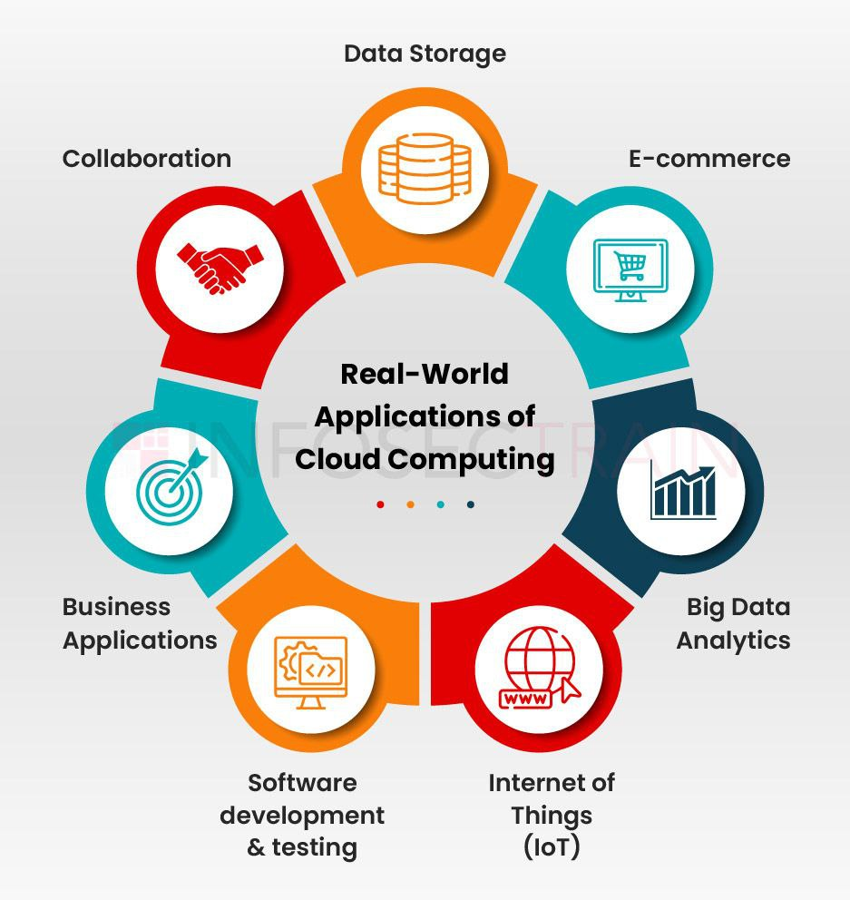
Cloud computing is used in many fields.

1. Education
Cloud computing supports online classes, digital notes, assignments, exams, and learning management systems.
Examples:
Google Classroom
Microsoft Teams
Moodle Cloud
Google Drive
Zoom
Case Example:
A college uses Google Classroom to share lecture notes, collect assignments, and conduct online discussions.

2. Business
Businesses use cloud computing for accounting, customer management, inventory, communication, and data analysis.
Examples:
Cloud accounting software
CRM systems
Online billing system
Cloud ERP
Business analytics dashboard
Case Example:
A small business uses cloud-based billing software to manage sales, stock, and customer records.

3. Healthcare
Hospitals use cloud systems to store patient records, manage appointments, and support telemedicine.
Examples:
Electronic Health Records
Online appointment system
Telemedicine platform
Medical image storage
Case Example:
A hospital stores patient reports in a cloud-based health information system so doctors can access records quickly.

4. Banking and Finance
Banks use cloud computing for digital banking, fraud detection, transaction processing, and customer support.
Examples:
Mobile banking
Online payment gateway
Fraud detection system
Financial analytics

5. Software Development
Developers use cloud platforms to build, test, deploy, and monitor applications.
Examples:
GitHub
AWS
Azure
Google Cloud
Docker cloud deployment
CI/CD pipelines
Case Example:
A software company deploys a web application on cloud so users can access it globally.

6. Entertainment
Cloud computing is used in video streaming, music streaming, online gaming, and content delivery.
Examples:
Netflix
YouTube
Spotify
Cloud gaming platforms

7. Government Services
Government organizations use cloud systems for digital records, citizen services, tax systems, and online forms.
Example:
Online passport application, tax payment, and digital identity systems.

8. Data Analytics and AI
Cloud platforms provide large computing power for big data, machine learning, and artificial intelligence.
Example:
A company analyzes customer purchase behavior using cloud-based analytics tools.

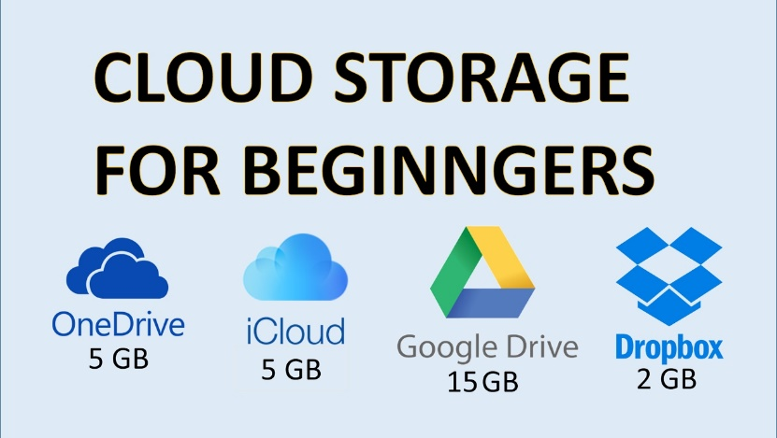
1.5 Introduction to cloud storage

Meaning of Cloud Storage
Cloud storage is a service that allows users to store data on remote servers accessed through the internet.
Instead of saving files only on a local computer, users save files in cloud storage and access them from anywhere.

Simple Examples of Cloud Storage
Google Drive
Dropbox
OneDrive
iCloud
Amazon S3

How Cloud Storage Works
User Device
↓ Internet
Cloud Storage Server
↓
Data Center
A user uploads a file from a mobile or computer. The file is stored in the cloud provider’s data center. The user can later download, share, or edit the file.

Features of Cloud Storage
Feature | Explanation | Example
File Upload | Store files online | Upload PDF to Google Drive
File Download | Retrieve files anytime | Download assignment file
File Sharing | Share with others | Share link with students
Synchronization | Same file available on multiple devices | Mobile and laptop sync
Backup | Protect from data loss | Auto backup of photos
Access Control | Give permission to users | View-only or edit access

Types of Cloud Storage
1. Personal Cloud Storage
Used by individuals for personal files.
Example:
Google Drive, iCloud, OneDrive.

2. Public Cloud Storage
Storage service offered by public cloud providers.
Example:
Amazon S3, Google Cloud Storage, Azure Blob Storage.

3. Private Cloud Storage
Storage used only by one organization.
Example:
A bank maintains its own private cloud storage for customer records.

4. Hybrid Cloud Storage
Combination of private and public cloud storage.
Example:
A hospital stores sensitive patient data in private cloud and general website data in public cloud.
Advantages of Cloud Storage
. Easy access from anywhere
. Automatic backup
. Easy sharing
. Saves local storage
. Scalable storage capacity
. Useful for collaboration

Risks of Cloud Storage
. Requires internet
. Security risk if password is weak
. Data privacy concern
. Cost increases with large storage
. Account hacking risk

1.6 Cloud service requirements

Cloud service requirements are the conditions or features needed to use cloud computing properly.
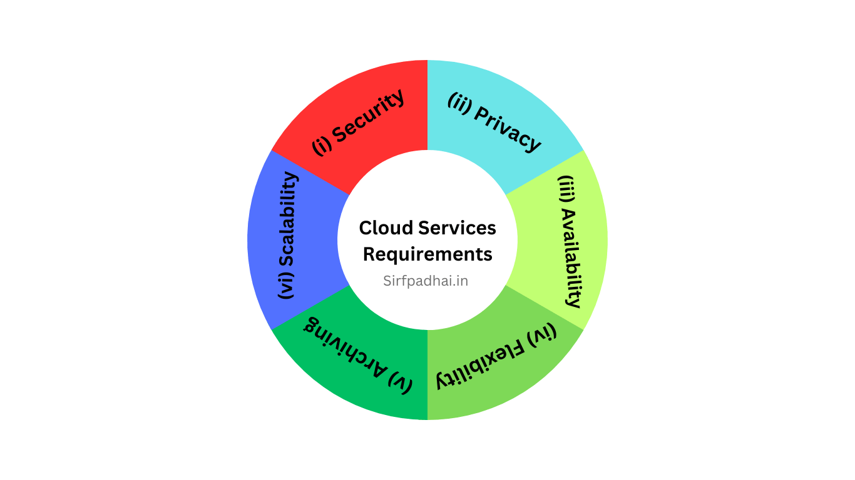

1. Reliable Internet Connection
Cloud services need stable internet.
Example:
Online classes using Zoom require reliable internet.

2. Security
Cloud services must protect data from unauthorized access.
Security includes:
. Strong password
. Multi-factor authentication
. Encryption
. Access control
. Firewall
. Backup

3. Performance
Cloud services should respond quickly and support many users.
Example:
An online exam system must handle many students at the same time.

4. Availability
Cloud service should be available whenever needed.
Example:
Banking systems must be available 24/7.

5. Scalability
The service must support growth.
Example:
A school management system may start with 500 students and later grow to 5,000 students.

6. Data Backup and Recovery
Cloud service should provide backup and recovery in case of failure.
Example:
If a file is deleted accidentally, the user should be able to recover it.

7. Compliance
Cloud services must follow legal and organizational rules.
Example:
Hospitals must protect patient data according to privacy rules.

8. Cost Control
Cloud services should be monitored to avoid unnecessary expenses.
Example:
Unused servers should be stopped to reduce cost.

9. User Management
Cloud services should allow proper user roles and permissions.
Example:
User Role | Permission
Admin | Full control
Teacher | Upload notes, manage class
Student | View notes, submit assignment
Guest | Limited access

1.7 Dynamic infrastructure

https://github.com/sanjeevlcc/notes_2081/blob/main/Artificial%20intelligence/Cloud%20Computing_2026/Notes_Blue/Unit%201/Lab3_Unit1_AutoScaling_k8_HPA.txt
Meaning of Dynamic Infrastructure
Dynamic infrastructure means cloud resources can automatically change according to workload or demand.
In traditional infrastructure, servers are fixed. In cloud infrastructure, servers, storage, and network resources can be added, removed, or adjusted dynamically.
Simple Example
An e-commerce website normally gets 1,000 visitors per day. During festival offers, it gets 50,000 visitors per day.
With dynamic cloud infrastructure, extra servers can be added automatically during high traffic and removed after traffic becomes normal.

Static Infrastructure vs Dynamic Infrastructure
Static Infrastructure | Dynamic Infrastructure
Fixed resources | Flexible resources
Manual scaling | Automatic scaling
More chance of overload | Handles changing demand
Higher unused cost | Better resource use
Slow deployment | Fast deployment
Important Components of Dynamic Infrastructure
1. Virtualization
Virtualization allows one physical server to run many virtual machines.
Example:
A cloud provider runs many customer servers on the same physical machine using virtualization.

2. Auto Scaling
Auto scaling automatically increases or decreases resources based on demand.
Example:
If CPU usage goes above 80%, cloud automatically adds another server.

3. Load Balancing
Load balancing distributes user requests across multiple servers.
Example:
If 10,000 users open a website, the load balancer sends requests to different servers so no single server becomes overloaded.

4. Elastic Storage
Storage can grow as data increases.
Example:
A college database grows every year as new student records are added.

5. Monitoring
Cloud systems continuously monitor CPU, memory, storage, network, and application performance.
Example:
Admin receives an alert when server storage reaches 90%.
https://github.com/sanjeevlcc/notes_2081/blob/main/Artificial%20intelligence/Cloud%20Computing_2026/Notes_Blue/Unit%201/Lab4_Unit1_Monitoring_k8_grafana%20and%20PROMETHEUS%20.txt

Dynamic Infrastructure Flow
User Requests Increase
↓
Monitoring Detects High Load
↓
Auto Scaling Adds More Servers
↓
Load Balancer Distributes Traffic
↓
Application Runs Smoothly
↓
Traffic Decreases
↓
Extra Servers Are Removed

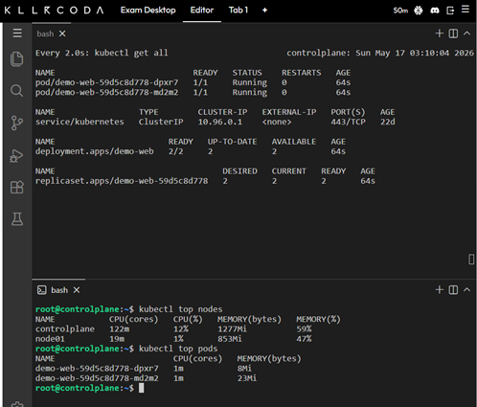
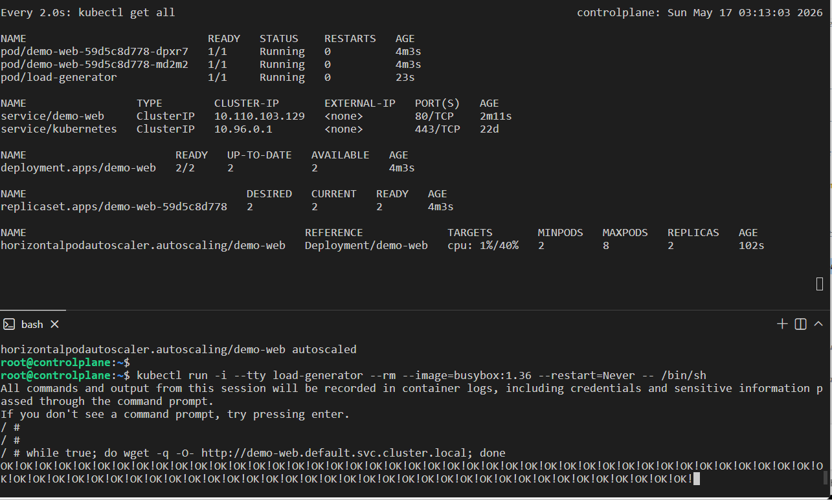
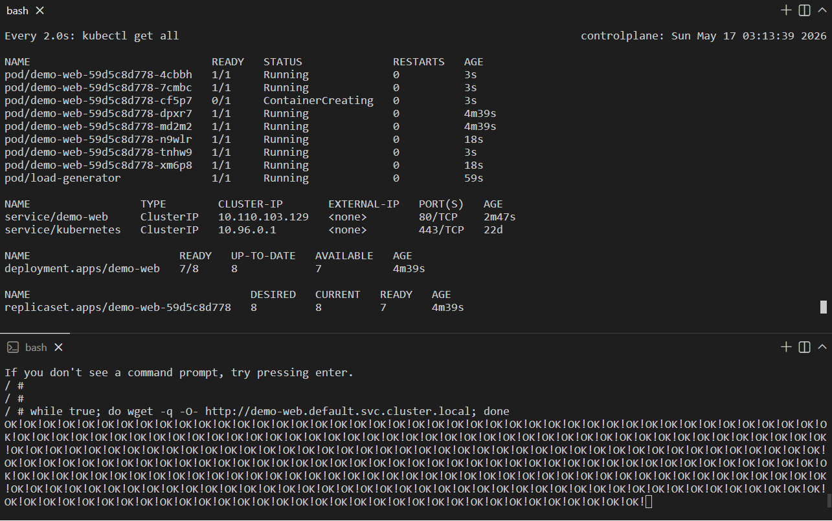

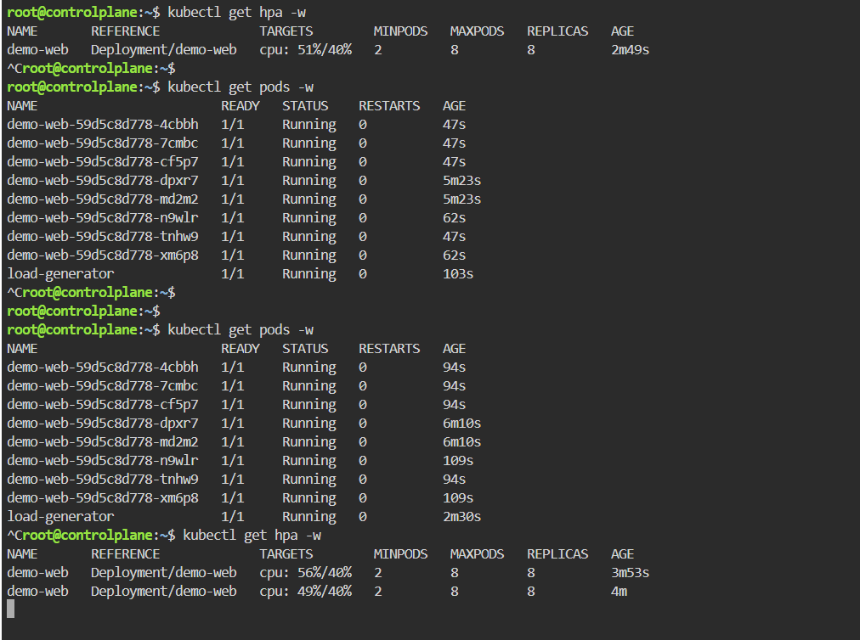
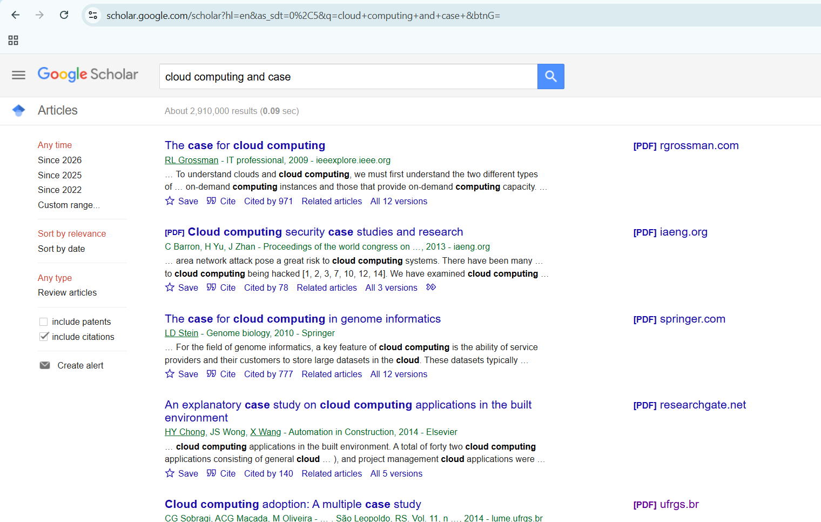
1.8 Cloud adoption strategies and case studies

Paper/ CASE
- https://lume.ufrgs.br/bitstream/handle/10183/99410/000921541.pdf?sequence=1&locale-attribute=en

- https://nepjol.info/index.php/jem/article/download/72890/55694

Meaning of Cloud Adoption
Cloud adoption means the process of moving an organization’s data, applications, or services from traditional systems to cloud platforms.

Cloud Adoption Strategies
1. Assess Current System
The organization should first study its current hardware, software, data, users, and security needs.
Example:
A college checks its current student management system, data size, number of users, and internet capacity.

2. Identify Business Needs
The organization should decide why it needs cloud computing.
Possible reasons:
. Reduce cost
. Improve backup
. Support remote work
. Improve scalability
. Modernize old systems
. Improve collaboration

3. Choose Cloud Deployment Model
There are four common deployment models.

Model | Meaning | Example
Public Cloud | Services offered to many users | AWS, Azure, Google Cloud
Private Cloud | Cloud used by one organization | Bank private cloud
Hybrid Cloud | Mix of public and private cloud | Hospital using both
Community Cloud | Shared by similar organizations | Government departments sharing infrastructure

4. Choose Cloud Service Model
Service Model | Full Form | Main Use | Example
IaaS | Infrastructure as a Service | Rent servers, storage, network | AWS EC2, Azure VM
PaaS | Platform as a Service | Develop and deploy apps | Google App Engine, Heroku
SaaS | Software as a Service | Use ready-made software | Gmail, Google Docs, Microsoft 365

IaaS, PaaS, SaaS Simple Comparison
IaaS: You rent infrastructure.
PaaS: You build application on provider platform.
SaaS: You directly use software.
Example
Requirement | Best Model
Need virtual server | IaaS
Need platform to deploy web app | PaaS
Need email and office tools | SaaS

5. Plan Security and Backup
Before moving to cloud, security planning is very important.
Security plan should include:
. User authentication
. Password policy
. Data encryption
. Backup policy
. Access control
. Disaster recovery plan

6. Start with Pilot Project
Instead of moving everything at once, organizations should first test cloud with a small project.
Example:
A college first moves only file sharing to Google Drive before moving the full college management system.

7. Train Users
Users must be trained to use cloud tools properly.
Example:
Teachers receive training on Google Classroom, Google Drive, and online assignment checking.

8. Migration
Migration means transferring data, applications, and services to the cloud.
Migration steps:
Step 1: Backup existing data
Step 2: Select cloud provider
Step 3: Prepare cloud environment
Step 4: Transfer data
Step 5: Test system
Step 6: Train users
Step 7: Go live
Step 8: Monitor performance

9. Monitor and Optimize
After cloud adoption, organizations should continuously monitor usage, cost, performance, and security.
Example:
A company checks monthly cloud bills and removes unused servers.

Cloud Adoption Strategy Diagram
Current System Assessment
↓
Business Requirement Analysis
↓
Cloud Model Selection
↓
Security and Backup Planning
↓
Pilot Testing
↓
Migration
↓
User Training
↓
Monitoring and Optimization

Case Studies

Case Study 1: Cloud Computing in College
Situation
A college has 1,500 students and 80 teachers. Previously, notices were printed on paper, assignments were submitted physically, and notes were shared through pen drives.
Problem
. High paper use
. Difficult assignment management
. Students losing notes
. Teachers unable to track submission properly
. Limited online collaboration
Cloud Solution
The college adopts cloud-based tools:
Google Workspace
Google Classroom
Google Drive
Google Meet
Cloud-based student database
Result
. Teachers upload notes online
. Students submit assignments through Google Classroom
. Online meetings are possible
. Data is stored safely in cloud
. Collaboration improves
Learning
Cloud computing improves communication, reduces paper work, and supports online education.

Case Study 2: Cloud Computing in Small Business
Situation
A small shop keeps sales records manually in notebooks. Stock records are not updated properly.
Problem
. Difficult to know available stock
. Sales calculation takes time
. Manual errors occur
. Owner cannot check business remotely
Cloud Solution
The shop uses a cloud-based billing and inventory system.
Result
. Sales are recorded automatically
. Stock updates after each sale
. Owner can check reports from mobile
. Monthly profit report is generated
Learning
Cloud computing helps small businesses manage sales, inventory, and reports easily.

Case Study 3: Cloud Computing in Hospital
Situation
A hospital stores patient records in paper files. Doctors need time to search old records.
Problem
. Slow access to patient history
. Risk of file loss
. Difficult report sharing
. Poor backup system
Cloud Solution
The hospital uses cloud-based electronic health record system.
Result
. Patient records are available quickly
. Doctors can access reports digitally
. Backup is maintained
. Appointment and billing become faster
Learning
Cloud computing improves healthcare service quality and record management.

Simple Real-Life Analogy
Cloud computing is like using electricity.
We do not produce electricity individually at home. We use electricity from a provider and pay according to usage.
Similarly, in cloud computing, we do not need to own large servers. We use computing resources from cloud providers and pay according to usage.

Case Study 4:

https://nepjol.info/index.php/jem/article/download/72890/55694
STUDY THE PAPER…….
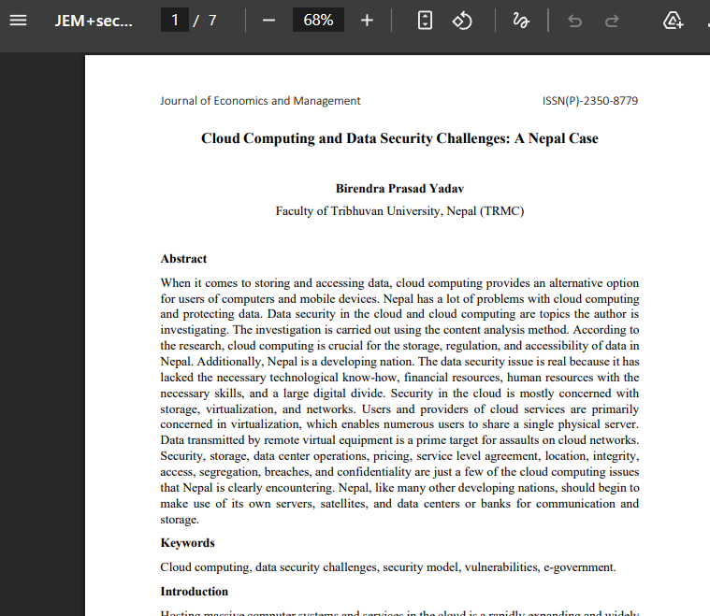
Basic Questions
- How does the paper define the role of cloud computing in data storage, access, and processing in Nepal?
- What cloud service models are discussed in the paper, and how do they differ in terms of user control and security responsibility?
- What are the major data security challenges identified in cloud computing adoption in Nepal?
Analytical Questions
- Why is data security considered a major barrier to cloud computing adoption in Nepal?
- How do virtualization, shared infrastructure, and multi-tenancy increase security risks in cloud computing environments?
- How do factors such as limited skilled manpower, financial constraints, and digital divide affect secure cloud implementation in Nepal?
- What role do Service Level Agreements play in ensuring trust, accountability, and security between cloud users and cloud service providers?
- How does the physical location of cloud data create legal, privacy, and compliance challenges for Nepalese organizations?
- To what extent can encryption, access control, firewall systems, and digital signatures reduce cloud security risks in Nepal?
- Why does the paper recommend that Nepal develop its own servers, data centers, and data banks for secure cloud adoption?

